Beginning Band Sign-Up
4th Grade Parents,
Welcome back! This will be a year full of musical possibilities for your child. During 4th grade, your child has the opportunity to participate in the instrumental music program. Please read the following information carefully and discuss the possibility of joining the band with your child.
Instruments
Students participating in band will need to obtain their own instrument, lesson book, and accessories. The instruments offered are at the beginning band level are: flute, clarinet, saxophone (alto or larger tenor), trumpet, trombone, baritone, and percussion.
We recommend renting an instrument rather than purchasing. Many companies offer a rent-to-own program. This will give your child an opportunity to try the instrument before making a large investment. Attached are instrument rental forms from the dealers that work with our schools. Please read the contracts carefully and select the company you would like to use. You should then send in the form, payment made out to the music company, and sign-up form at the end of this letter with your child to school. If you decided to use an online rental contact or already have an instrument, please return the sign-up form at the end of this letter. You can obtain an instrument from any company of your choice, but please be aware of “no-name” instrument brands. These instruments tend to break easily and cause student frustration. If you already have an instrument, please make sure it is serviced properly prior to the start of the school year.
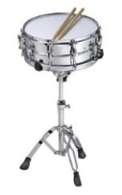
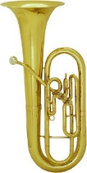
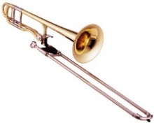
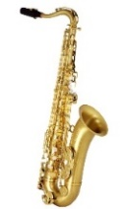
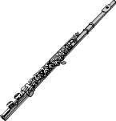
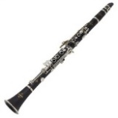
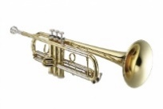

flute clarinet saxophone trumpet trombone baritone percussion
In order to create a balanced band, it is necessary to limit the number of beginning percussionists to five students at each elementary school. When too many students select the drums, they are often not able to play during every song at the band concert. Parents of students wishing to play percussion should contact their music teacher as soon as possible (via email is quickest, as the first 4 students will be taken) and be sure to indicate an alternate choice on the attached form.
Other Materials
- Lesson Book - In addition to an instrument, your child will need a lesson book. The required book is Essential Elements, Book 1. Please include this on your order form. The price is $15.30 for percussion and $9.00 for all other instruments.
- Reeds - Saxophone and clarinet students should order reeds (size 2). Two are supplied with the instrument rental, but a surplus (at least 3-4) should be available at home/school in case of emergency.
- Oils - Brass students should receive a small bottle of valve/slide oil with their instrument rental; one more may be needed midyear.
- Music Stand - A music stand can be ordered with your instrument rental. It is not required to begin band, but is recommended for practice at home.

Lessons and Rehearsals
- Lessons - Instrument lessons will begin the week of September 24th. Lessons take place during the school day, 30 minutes once a week. Your child’s music teacher will inform them of their lesson day and time, based on their instrument choice.
- Sectionals - These rehearsals take place before school on Thursdays (7:55am-8:35am) beginning on September 30th through December. Each instrument group will have assigned sectional rehearsals and students are required to attend when their section is scheduled. A Sectional Schedule will be distributed with your child’s beginning band materials.
- Band - Full band rehearsals (consisting of ALL band students) will take place before school every Thursday (7:55-8:35) beginning January 3rd and continuing until our concert in May.
**Before-school Care is available to siblings of band students on Thursdays, beginning at 7:40am.

Practice
Beginning band students should practice a minimum of 15-20 minutes per day, 3 days a week. Parents are encouraged to help your child succeed by creating a regular time and quiet place for practice. Please monitor your child’s practice at home. Practice logs will be turned in weekly at lessons. Developing consistent practice habits is an extremely important part of our beginning band program.
If you and your child have decided that he/she would like to join the band, please fill out the form below and return it with additional paperwork (rental form, check, etc.) to your child’s music teacher as soon as possible. Band sign-up forms should be returned no later than Thursday, September 13th. This will give the instrument companies time to deliver the instruments and materials.
Remember, band is a big commitment. However, it is one that can be very rewarding and beneficial for your child. It is our hope that your child will commit to band for the full year. The first performance will be an instrumental recital, which will take place within the winter concert at each elementary school on December 11th. Also mark your calendars for our Elementary Band Festival which will be in May at HKMS.
If you have any questions or concerns, do not hesitate to contact your child’s music teacher. Thank you for considering this great opportunity for your child!

RSD 17 Elementary Music Teachers

Kelly Johnson, Haddam Elementary School kjohnson@rsd17.org

Amy Stern, Burr Elementary School astern@rsd17.org

Irina Rubalsky, Killingworth Elementary School irubalsky@ rsd17.org

------------------------ Please detach and return to music teacher by September 13th-----------------------------

Student Name: ___________________________________ Class: _______________

Parent/Guardian Name: _________________________________________________

Email: _____________________________________ Phone: ____________________

_____ Yes, my child will be participating in the beginning band.

_____The rental contract from ______________________ (with payment) is attached.
(Name of Instrument Company) Did you include the cost of the
lesson book?

_____I am obtaining the instrument from another source.

Instrument _______________________ 2nd Choice (if percussion) _______________

